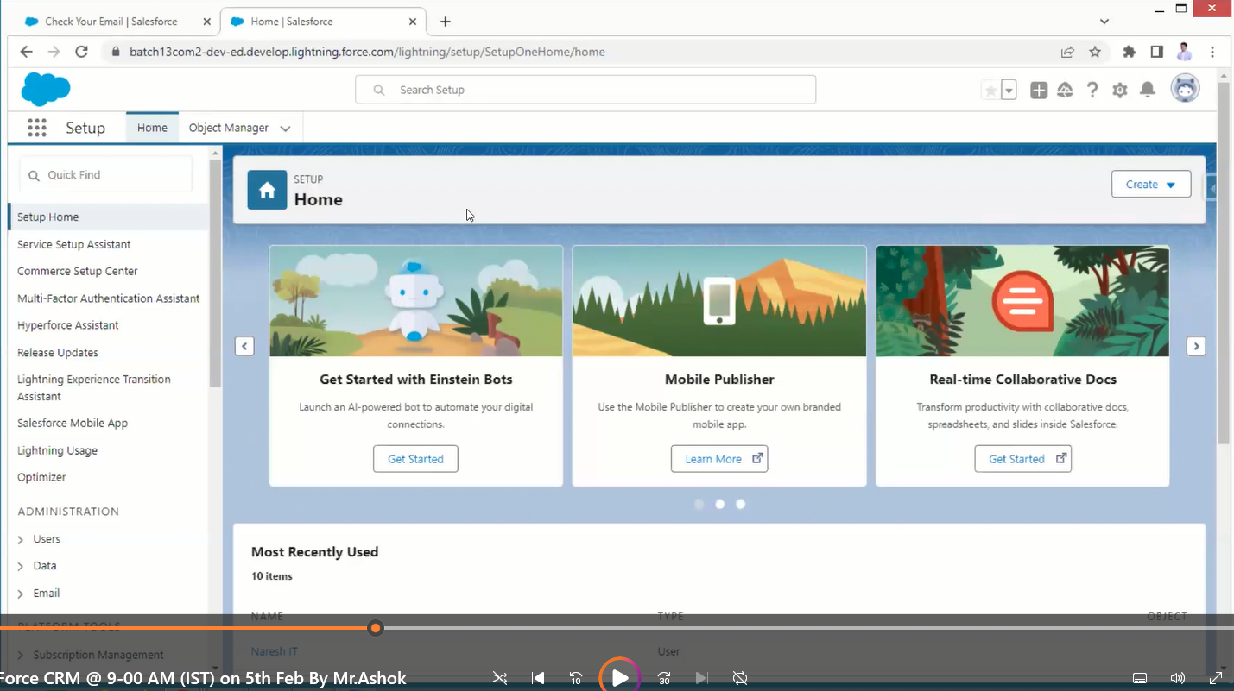

This is a lightning experience

The old UI is called classic

Now work with class then move to lightning

Object name always word or word including _.

If labels contain special characters or space, then in object names it will be replaced with underscore _.

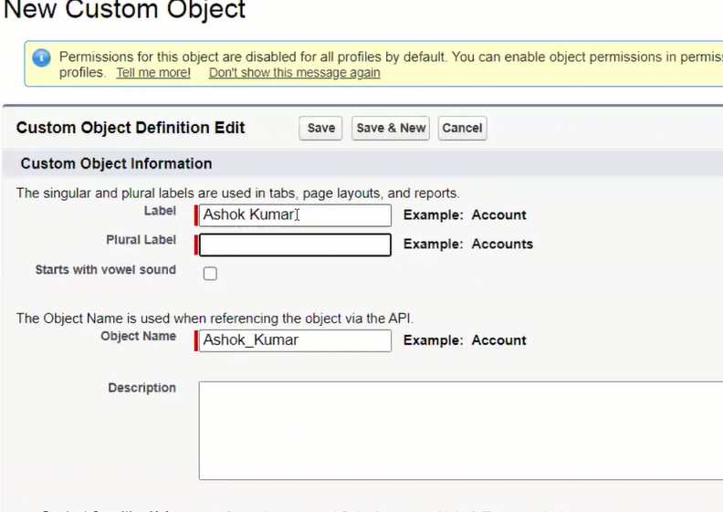

If we have special characters and space at the start or ending it won’t be considered.

When you are creating the object by default one column(filed) is created automatically.

API name is also automatically created which will be given by user (Username) by default.

It is like a unique identity

C means custom

API--Application Programming Interface

When you are creating objects by default 4 fields are created by salesforce

